D424 – Software Engineering
Task 3
Capstone Proposal Project Name: |   Degree Planner
Student Name: | Galen Hammerle

Table of Contents
Task 3 Design Document 4
Application Design and Testing 4
Class Design 4
Database Repository Design 4
User Interface Design 5
UI Design 6
Unit Test Plan 8
Introduction 8
Purpose 8
Overview 8
Test Plan 8
Items 8
Features 9
Deliverables 9
Set up for Functional Test Session using Visual Studio 10
Set up for Functional Test Session using an Android device 10
Application Start 10
User Security and Login Test 11
Pass/Fail Criteria 11
Database Seeding Test 12
Pass/Fail Criteria 13
Create and Delete Student Test 13
Pass/Fail Criteria 14
Edit Create a Major Test 15
Pass/Fail Criteria 16
Student Workflow Test 17
Pass/Fail Criteria 18
Unit Tests 19
User Guide 22
Introduction 22
Installation and Using the Application 22
Installation (Visual Studio 2022 Setup) 22
Login 24
Administrator Workflow 25
Student Workflow 30

Task 3 Design Document

Application Design and Testing

Class Design
The project utilizes two main elements: a user interface and a database. UML details of each design are provided below.

Database Repository Design
An interface defining the API to the database allows the database to be abstracted from the user interface. The DataRepositoryBase class is abstract and implements IDataRepository. DataRepositoryBase can implement methods that are not reliant on the concrete database implementation. This pattern allows us to keep business logic out of the user interface. This pattern also makes implementing a different database easier if it needs to be changed.
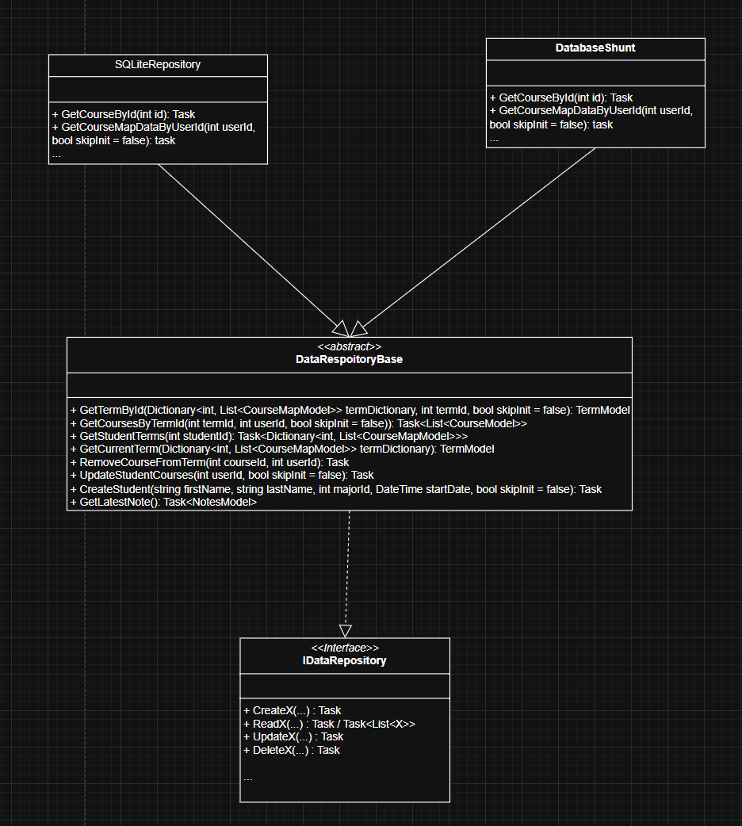
Figure 1 Data Repository UML

User Interface Design
BaseContentPage was created to provide standard functionality to all pages of the application. This reduces duplicated code and standardizes functionality. This base class provides:
- The ability to present dialogs to the user for success and errors.
- Shared access to IDataRepository and ActiveUserId.
- Event logging functionality.
- Report generation.
Reports generated from a page provide a ContentView to the ReportPage (a ContentPage). This allows for easy addition of reports; create a new ContentView for the report and update the page to call the inherited ShowReportPopupAsync method.
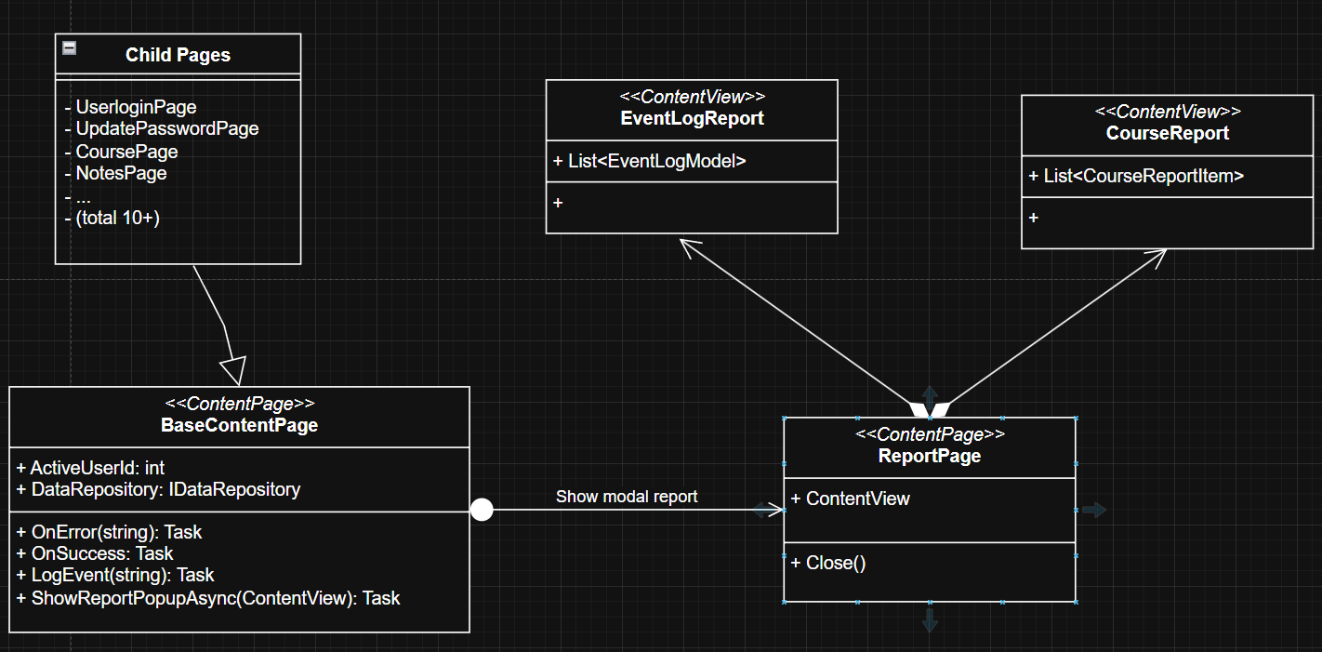
Figure 2 Content Page UML

UI Design
The user interface was designed to support two types of users, administrators and students. The user interface was mocked using a low-fidelity wireframe created with Software Ideas Modeler. Students are presented with the current or following term when they log in. Students can then view courses in the term and add notes for each course. Administrators are presented with a list of tasks they can perform. The low-fidelity wireframe captured in the images below served as a guide to the application's development.
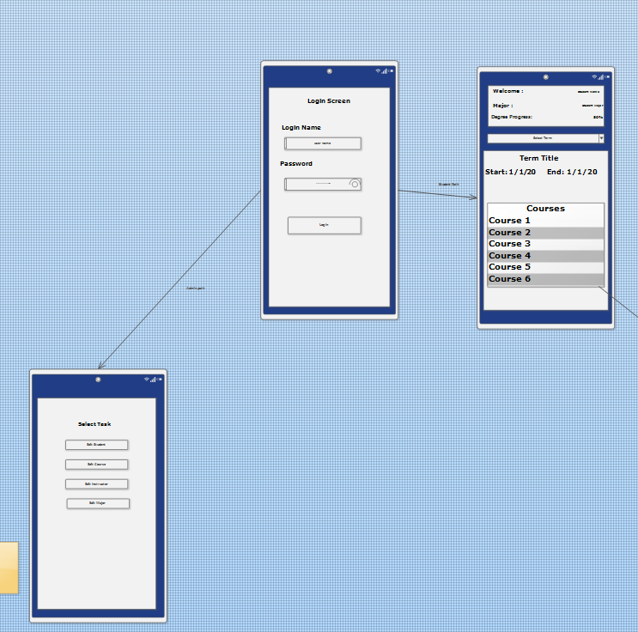
Figure 3 Initial Flow
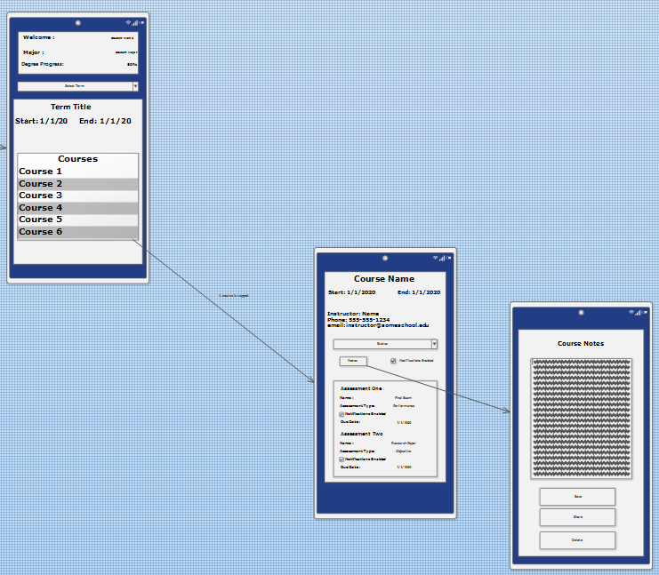
Figure 4 Student Workflow
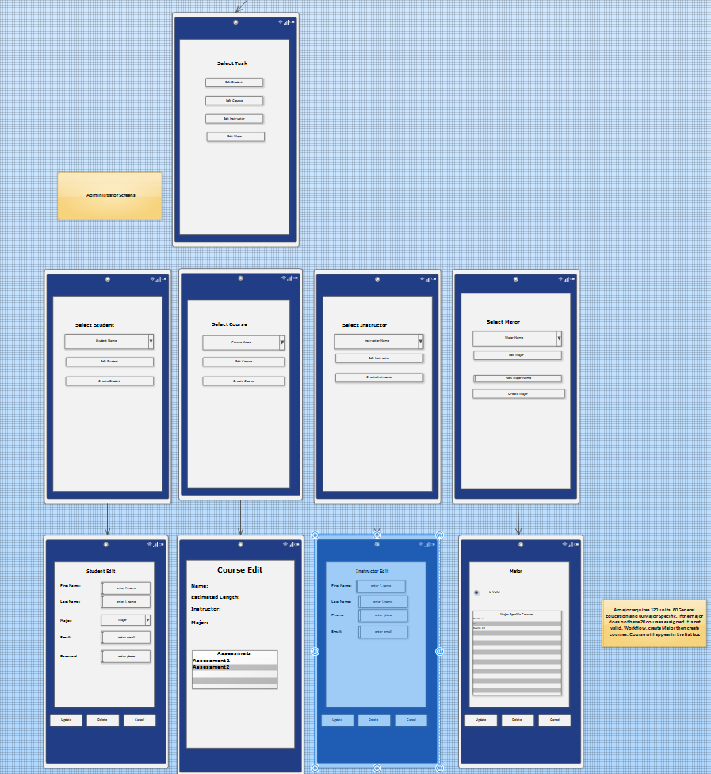
Figure 5 Admin Workflow

Unit Test Plan

Introduction

Purpose
Most of the testing of this application was functional testing performed during development. Unit tests were also utilized to test portions of the code. The testing used ensured the reliability and functionality of the application.

Overview
The application is delivered with files to seed the database. These files are installed with the application. The database will be seeded when a user attempts to log in for the first time. The database will be seeded with three users: one administrator and two students. With the seeded data, all functional testing is possible. During the development phase, the functional tests were performed. Errors encountered during development were resolved using the Visual Studio 2022 built-in debugger, adding code to write to the console, and conducting internet searches.
The following section details functional tests for key features of the two user types and unit tests.

Test Plan

Items
The latest version of the application source code is located here: https://gitlab.com/wgu-gitlab-environment/student-repos/ghamme3/d424-software-engineering-capstone.git
Visual Studio 2022 Community Edition, with support for .NET MAUI development.

Features

General Features
- User security and login.
- Database seeding

Administrator Features
- Create a new major
- Create new courses in General Education & for the new major
- Create and Delete a student
- View Reports for courses, the event log

Student Features
- View terms
- Drop a course, major & general education
- Add a course, including search
- Add notes for a course

Deliverables
There are no expected deliverables for the functional test being performed. Any testing that did not result in a working feature or function was addressed immediately. Once a key feature was considered working, the code would be committed to the branch. If the testing was performed by an independent user, an issue detailing the concern should be created in the GitLab repository.
Unit tests are expected to be run and all pass prior to pushing any changes to the repository.

Set up for Functional Test Session using Visual Studio
Open the solution using Visual Studio 2022 Community Edition.
Rebuild the solution.
Start the emulator.
Tools Android Device Manager
Start the device (Pixel 7 – API 35 with Android 15.0 – API 35 used for all testing and development)
Clean old versions and data as necessary. (New installations will not require this step)
Tools Android Android Adb Command Prompt
Run this command adb shell pm clear com.companyname.c424assessment
The command will return `Success`. If no devices are found, make sure the device is running.
Start the application without Ctrl+F5

Set up for Functional Test Session using an Android device
….. install the application…..
…… start the application …….

Application Start
When the application has been successfully installed and started, a dialog asking to allow notifications will appear. Click `Allow`.
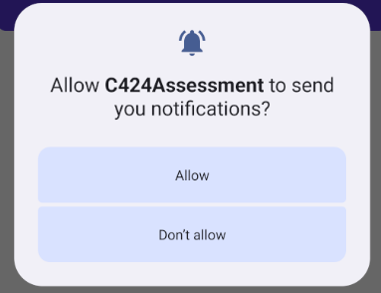
Figure 6 Notification permission
The user login screen will appear. This is the entry point for all users.
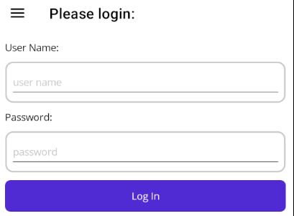
Figure 7 User login Screen
The application is now ready for functional testing.

User Security and Login Test
The first attempt at a login will seed the database (a slight lag is possible) with three users and passwords.
- User Name: admin Password: Admin123!
- User Name: Beth.Santos Password: BethSantosPW
- User Name: Jake.Smith Password: JakeSmithPW

Pass/Fail Criteria
If an incorrect user name or password is entered, the user will be prompted to resolve the issue.
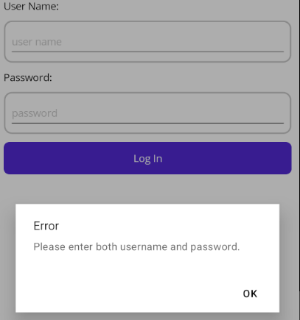
Figure 8 Invalid Login Example
Upon a successful login user `admin` will navigate to the Select Task Page.
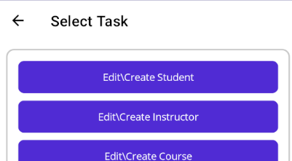
Figure 9 Select Task Page
Users `Beth Santos` and `Jake Smith` will be asked to change their passwords.
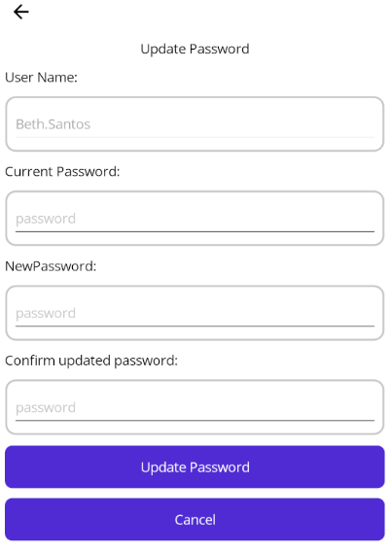
Figure 10 Update password Page
Password updates are validated against the correct current password, and the new password entries must match. (For simplicity, there are no added requirements for the new password.) The user will be prompted for validation issues or success. After a successful change, the user will return to the login page.

Database Seeding Test
The act of logging in is expected to seed the database. This can be validated by logging in as `admin` and viewing the Course Report.
Log in using `admin` password `Admin123!`.
Click the Generate Course Report button.
Course Report shows a list of all courses, the associated major (if any), and the number of students enrolled.
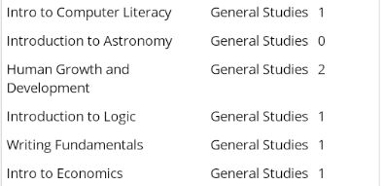
Figure 11 Course Report Snip

Pass/Fail Criteria
The database is expected to be seeded with a list of courses, two students and two majors. The two students are enrolled in different degree plans, one for Computer Science and the other for Biology. The Course Report will reflect this, as the course for each major will have one student enrolled.
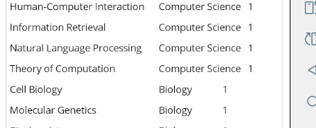
Figure 12 Major Enrolled Students Snip

Create and Delete Student Test
The admin user is expected to have the ability to create, update, and delete users. Users who have started courses cannot be deleted.
Log in using `admin` password `Admin123!`.
Select Edit\Create Student
Complete the fields as in the figure below. And click Update.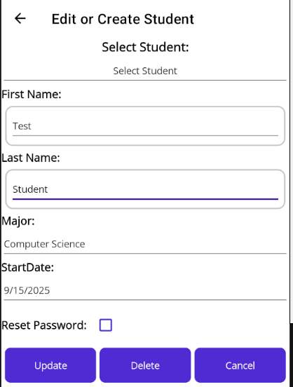
Figure 13 New Student Creation
Return to the Create Student Page and select the new student. The data should be populated with what was entered. Return to the Select Task page using Cancel.
Generate a course report and notice that some General Studies courses now have 3 enrolled and the major listed above now has 2 students enrolled.
Close the report and return to the Edit Student page.
Select and delete the new student.
Verify all student data has been removed by viewing the course report.
New students will be named First.Last and have a default password of FirstLastPW.

Pass/Fail Criteria
The Select Student Picker is expected to list all students.
Data entry fields shall be validated.
The Select Major Picker is expected to list all active majors.
(An active major is one with 20 related courses.)
If a student with progress toward their degree is selected, the data field will populate, and the user cannot be deleted.
The Reset Password check box shall be enabled.
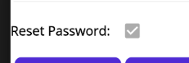
Figure 14 Failed Result Reset Password

The Start Date Picker will not allow selection of dates in the past.
The Start Date Picker will be disabled for students who have started their degree plan.
For a new student Reset Password value will not be honored when the student is created.
If the new student is deleted, all mapped course data will be removed.

Edit Create a Major Test
The admin user can create Majors and courses. A major must have 20 course to be considered active. Courses cannot be shared between majors. Inactive majors can not be assigned to students.
Log in using `admin` password `Admin123!`.
Select the Create\Edit Major Button.
Select an existing major and observe behavior.
Cancel and return to the Create\Edit Major page.
Add a name for the new major, click Update.
Return to the Create\Edit Major page.
Select the recently added major. Click add course.
The course edit page will appear, allowing the user to enter course information.
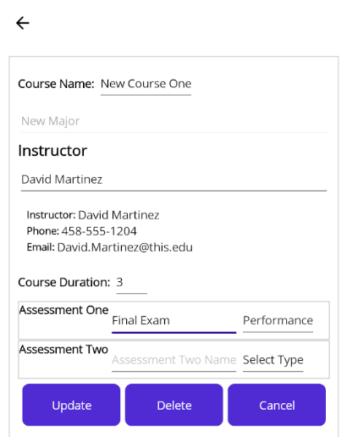
Figure 15 Course Edit Page
Click update. The Create\Edit Major Page will reload with the created course.
Return to the Select Task page using Cancel.
Go to Edit\Create Student page. Try to assign the new major. The new major will not appear until it is active (has 20 courses).
View the Course Report and see that the new course and major are in the database.
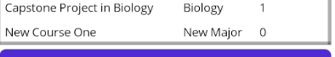
Figure 16 New major and Course Report
Once all 20 courses are assigned to the major, a new student can be enrolled for the degree plan.
Return to Create\Edit major and delete the major.

Pass/Fail Criteria
Data and action validation issues will notify the user.
Any major in which a student is enrolled cannot be deleted.
A major cannot have more than 20 courses.
A course created for the major will be linked to the major.
The Edit\Create course page will validate inputs.
Course name
At least one assessment.
If there are two assessments, they must be of different types.

Student Workflow Test
Students will have the following abilities:
- View all terms
- Remove a course from a term.
- Add a course to a term.

Log in as Beth.Santos password BethSantosPW unless it was updated.
(If the password was forgotten, use the admin account to reset the password to the default, or reseed the database as admin.)
In the current term click on a course to view the details.
Change the status of two courses: set one to Active and one to Completed.
For a third course, disable notifications
Use the update button to save the changes.
Log out and back in as the same user.
A different set of notifications should occur.
Select a course to remove from the term.

Pass/Fail Criteria
User Beth.Santos and Jake.Smith have seeded data as if they have started their respective degree programs.
Notification for seeded users will generate notifications. If the course has not started the notification will inform the user that the term is ending soon.
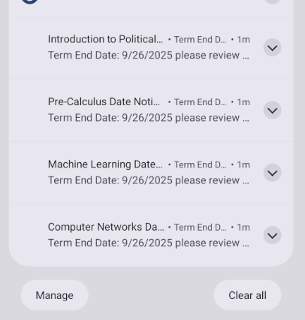
Figure 1717 Term Ending Notification

Completed courses and courses with notifications disabled will not have any alerts. An active course will notify the user of available assessments.
Completed courses cannot be removed from the term.
Setting a course status to Completed will update the percentage complete value.
A course must have at least one course and no more than six.
If a course is added from a different term. Both terms will reflect this change.
Major courses cannot be dropped; they will be moved to the following term, which can hold the course.
If a General Studies course is dropped, the student will see that they are not enrolled in enough units for graduation.

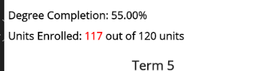
Figure 188 Not Enough Units

Prior to dropping a course, the student will be notified of the expected result of the action and the option to continue.

Unit Tests
The repository contains unit tests. These tests can be run using Visual Studio 2022 Community Edition. A shunt class derived from DataRespositoryBase was created to test the logic of a certain method, without relying on a concrete SQLite-PCL database to be instantiated.
The shunt class creates mock data when a test is run and provides this data to the test method.
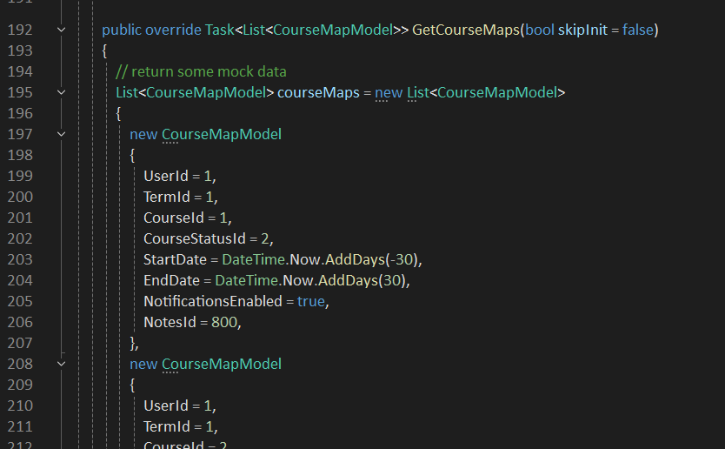
Figure 19 DataRepository Shunt Mock Data
When tests are run, a common setup method creates a DatabaseShunt. See figure 20 for more information.
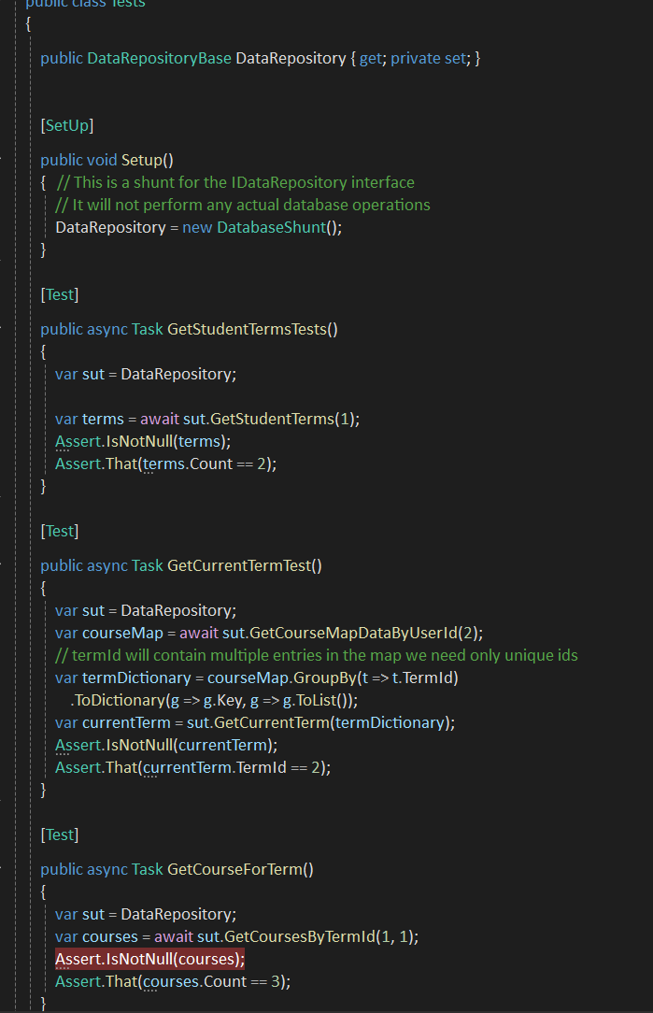
Figure 20 Test Case Examples
Visual Studio discovers unit tests when the project is built. To run the tests, use the Test Explorer window or, from the navigation menu, select Test Run All Tests.
All Results from the unit test are visible in the Test Explorer window in Visual Studio.
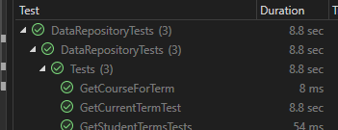
Figure 21 Unit Test Results

User Guide

Introduction
This user manual will provide installation instructions and key workflow steps for the two user types. Instructions for the admin user to log in and create a new major, including creating students and courses. The instructions for student users will cover the primary student workflow of viewing a term, viewing a course in the term, updating course status, disabling notifications, and adding notes to a course. Directions on dropping and adding a course will also be provided.
.

Installation and Using the Application

The application apk file is available for download on Github:
https://ghammerle.github.io/WGU-D424-Capstone/.
The source code is available on Gitlab:
Task 3 · working · WGU GitLab Environment / Student Repos / ghamme3 / D424 Software Engineering Capstone · GitLab.

Installation (Visual Studio 2022 Setup)
All instructions below assume the computer is set up for mobile .NET MAUI development using Visual Studio 2022 Community Edition, git is installed, and the computer has internet access.
PC Setup for development and testing:
- Windows 11
- Intel i5-12400 12th Gen
- Radeon RX550/550 Series GPU
- 16GB of RAM
(Testing conducted on a PC with lesser graphics performance resulted in emulator launch issues. The emulator had to be started through the command line to avoid the graphics-related issue. “C:Program Files (x86)\Android\android-sdk\emulator.exe” -avd pixel_7_-_api_52_1 – gpu swiftshader_indirect -verbose, it is best to avoid this complication.)

Open the Command Prompt. (Type cmd, and press Enter in the Windows search bar)
Create a working directory.
Navigate to the working directory and type git init to initialize git for this folder.
Navigate to the source code repository:
Task 3 · working · WGU GitLab Environment / Student Repos / ghamme3 / D424 Software Engineering Capstone · GitLab
Clone the repository, click code, and copy the path based on your account configuration.

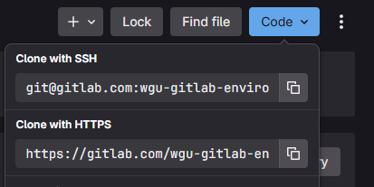
Figure 22 Git clone path

Return to Command Prompt, type git <path> (paste the copied path using Ctrl + V), and press Enter.
The repository will be cloned to the directory.
Check out the branch named working.
git checkout working
Open Visual Studio, open the solution C424 Capstone.sln
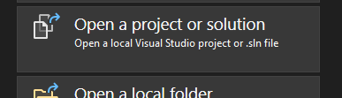

Figure 23 Open Solution

A directory navigation window will appear when the above selection is made.
Once the solution is loaded, use Tool Android Android Device Manager
Set up an Android device, the default was used to generate:
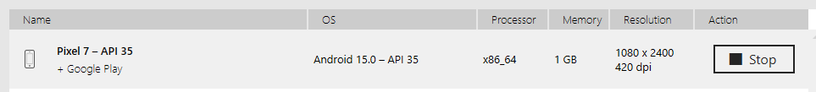
Figure 24 Android Pixel 7

Login
The application database comes seeded with three users.
- User Name: admin Password: Admin123!
- User Name: Beth.Santos Password: BethSantosPW
- User Name: Jake.Smith Password: JakeSmithPW
Students added to the database will have login credentials of
- User Name: First.Last Password: FirstLastPW
Students will be prompted to update the password on their initial login or if the admin resets it to the default password.
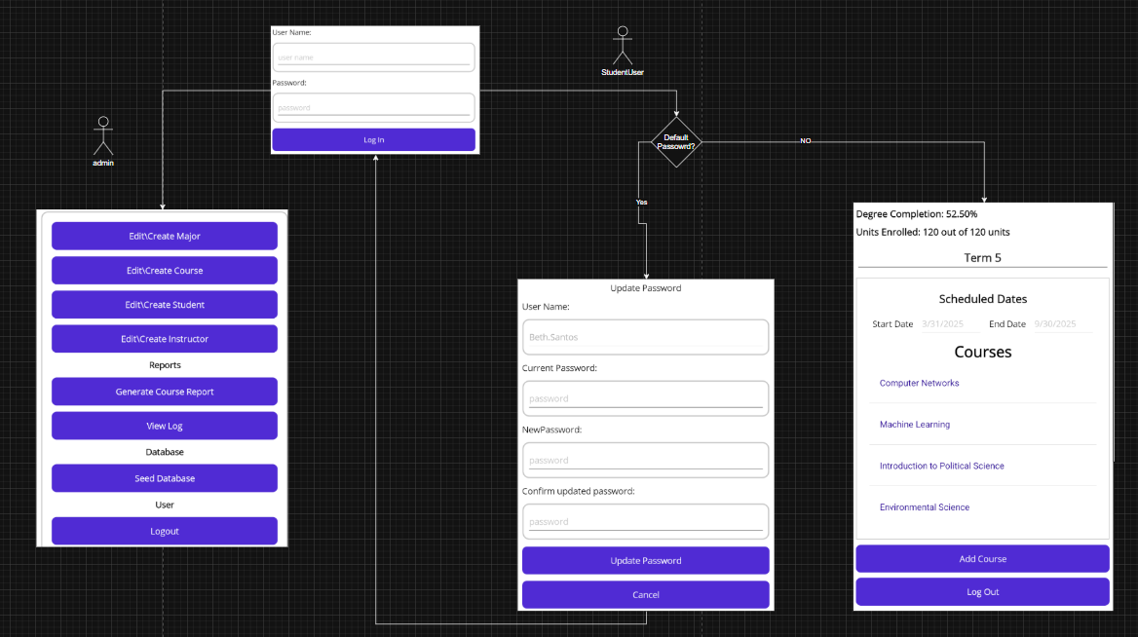
Figure 25 User Log in Flow

Administrator Workflow
The workflow detailed below will touch on major features available to the administrator user. Items covered will be adding and updating courses, majors, students, and instructors. Viewing reports and database seeding will also be covered.
- Log in as admin.
  - User Name: admin Password: Admin123!
- On the Select Task page, select Generate Course Report

  - This will show a report of all courses in the database, the associated major, and the number of students enrolled. Notice: Test Major has zero students enrolled.
  - Close the report
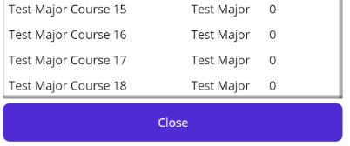
- Select Edit/Create Student
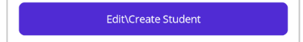
  - Using the Select Student Picker select a student.
    - Students who have started courses can only have their passwords reset to default.
    - Cancel and return to the Edit Student page.
  - Using the select Major picker choose a major 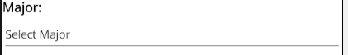
    - Notice only active majors are available. An active major is one with 20 associated courses.
  - Close the Edit Student Page using the Cancel button.
- From the Select Task page select Edit\Create Major. 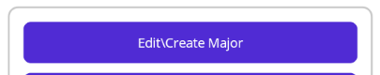
  - Select a Major
  - The associated course will appear. 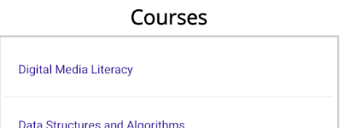
  - Tap (click on) a course
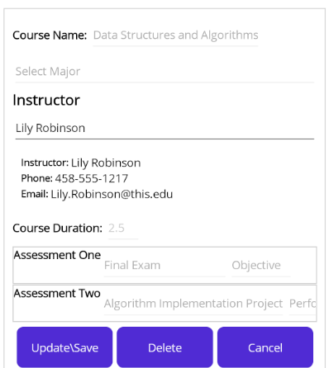
    - If a course is assigned to a student only the instructor can be edited.
  - Click Cancel to return to the Edit Major page.
  - Click the Add Course Button.
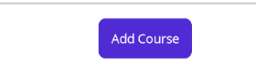
    - If the Major already has 20 courses, you cannot add a course.
  - From the Create\Edit Major page use the Major Picker to select Test Major.
    - This major was seeded with 18 courses for demonstration and training purposes.
  - Click Add Course
  - Enter a Course Name, select an instructor, and add at least one assessment.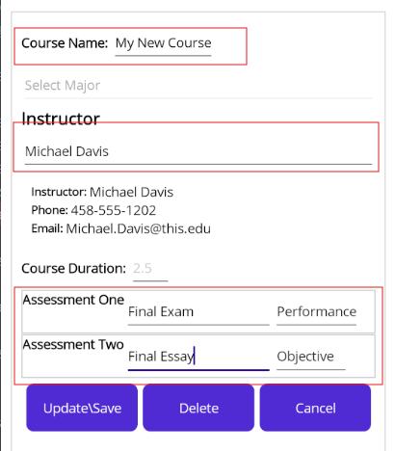
    - A course must have one assessment and no more than two. Assessments cannot be of the same type (Objective & Performance).
    - Click Update\Save to add the course to the major.
    - The course will appear in the list for the selected major. 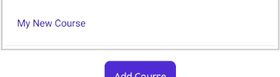
  - Add a second course to Test Major, making it active.
- Return to the Edit\Create student page.
  - Create a student and assign the major of Test Major. Provide first and last names and a start date. (Start Date can no be in the past.)
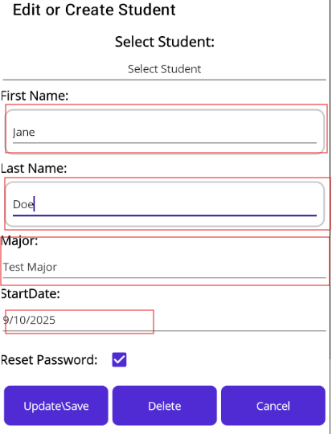
  - Click Update\Save to add the student.
- To verify if a student was added to the major use the Generate Course Report button to view the course report.
  - Notice that Test Major courses have one student enrolled and some general education courses now have three students enrolled.
  - The two courses added earlier will also appear in the report.
- Delete a Major.
  - Open the Create\Edit Major, select any major
    - Majors which have students enrolled in cannot be deleted.
  - Return to the Task Selection page using Cancel.
- Delete a student
  - Open the Create\Edit Student page, select the newly added student.
    - Students who started courses cannot be deleted.
  - Click the delete button to remove the selected student.
  - Validate the student has been deleted using the Course Report.
    - The View Log button on the Select Task page will generate a report of the event log showing various events.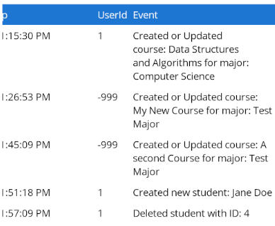
  - Open Create\Edit Major
    - Select Test Major from the Select Major picker.
    - Click Delete, if no students are enrolled in this major the major can be deleted.
  - Return to the Select Task Page and select Edit\Create Course.
    - If a major does not contain 20 courses, it will be available from the Select Major picker.
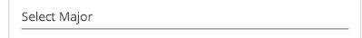
    - Create a new course for General Education
      - Like adding course to a major directly, fill in the data but do not select a Major. Save the changes.
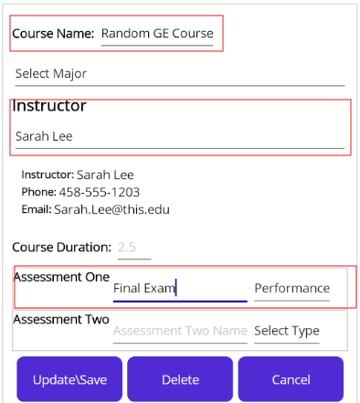
      - Use Generate Course Report to validate the course was saved.
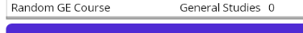
  - Seeding the database
    - The admin user can reset the database to the initial values using the Seed Database button on the Select Task page.

    - Click the button and wait for the dialog informing you that the database action is completed.

Student Workflow
- Log in as a student. (Beth Santos used for the example)
  - There are two students provided.
    - Beth.Santos Password BethSantosPW
    - Jake.Smith Passoword Jake.SmithPW
  - Newly created students are defined with a pattern
    - FirstName.LastName Password : FirstNameLastNamePW
  - When the password is the default students will be prompted to enter a new password.
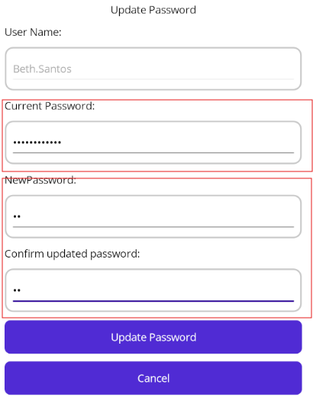
    - The current password must be entered, and the new password must be entered twice for confirmation. (There is no secondary validation of passwords for length or reuse. This is done to simplify rapid testing.)
    - After updating their password, users will need to log in using their new password.
    - The students provided were set up as if they were nearing the end of a term. When logged in, they should receive notifications. 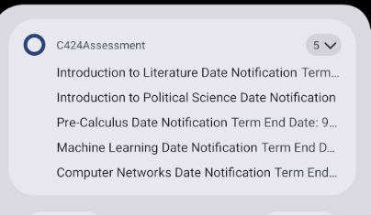
    - Students will see their progress and Units enrolled. The application will open to their current term.
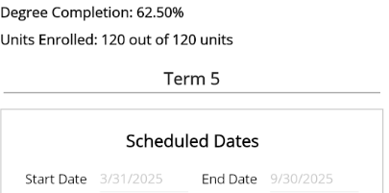
  - Drop a course from a term.
    - Select a Course
      - A course can be dropped from a term as long as the term will have at least 1 course remaining. If a general course is dropped, the user will need to add a course to get back to the required 120 units to graduate. Courses required for the enrolled major will move to the next available term.
      - Pop-ups will occur to let the user understand the action.
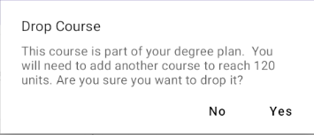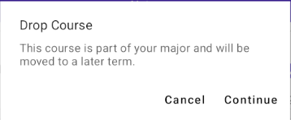
      - Courses are randomly selected so that the examples may vary.
    - When a course is selected, the course view will open
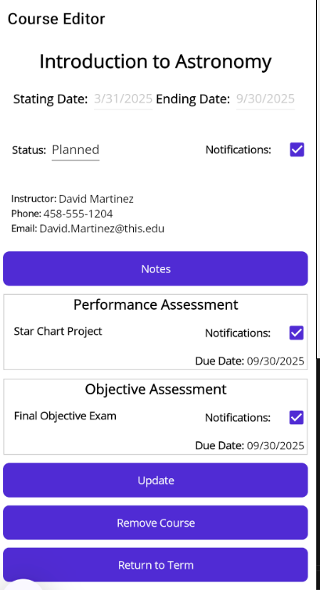
    - Select Remove Course
      - After removing one general education course and one major course from the term, the user will see fewer courses, and the enrolled units will be updated.
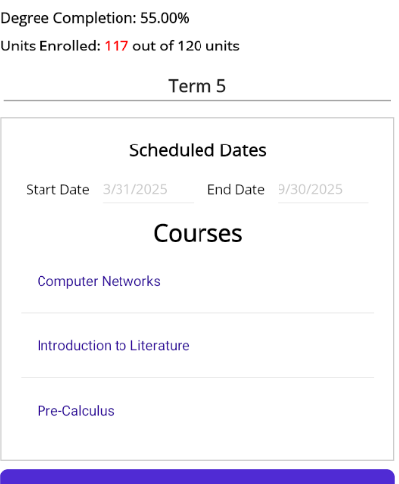
    - Select Add Course
      - The user can select a course to add to the term.
      - The Select a Course picker will list courses available to the user.
        - This includes courses that may exist in future terms.
      - A search filter is available to filter the selection.
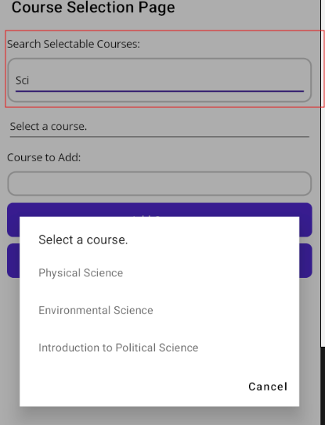
    - Click Add Course once a selection has been made.
    - The course will be added to the current Term.
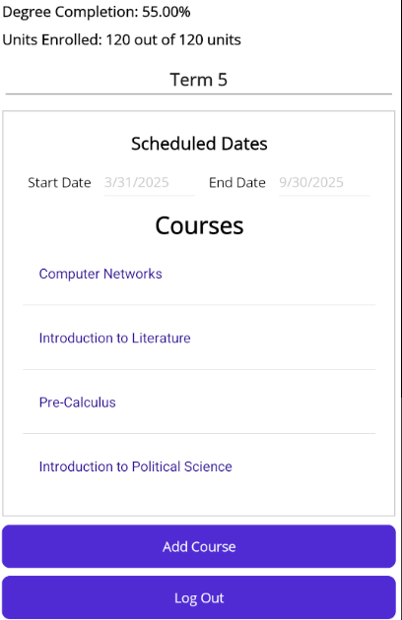
  - Updating Notifications
    - Notifications are for a course and will be triggered if a course has not started and the term will end in the next 30 days.
    - Notifications can be disabled by course and assessment. Course settings take precedence.
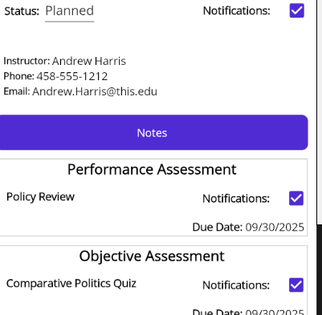
    - Notification flow chart
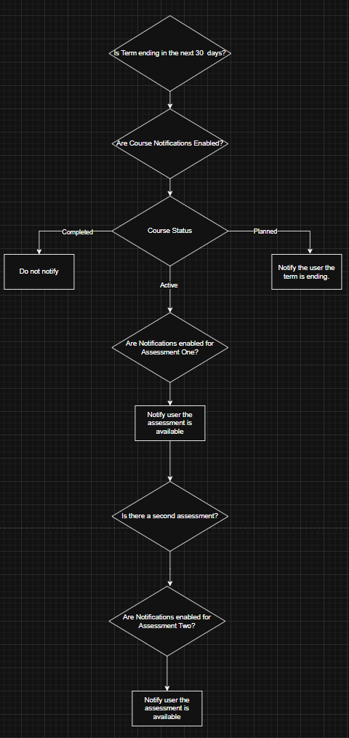
  - Updating Course Status
    - Navigate to the current term
    - Use the status picker to set a course to completed.
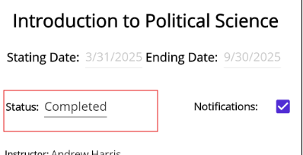
    - Click Update to save the changes.
    - Notice that the degree completion percentage has been updated.
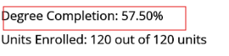
  - Adding and sharing course notes.
    - From the Term Page, select a course.
    - In the Course Page, click the Notes button.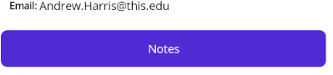
    - Add content in the note entry field.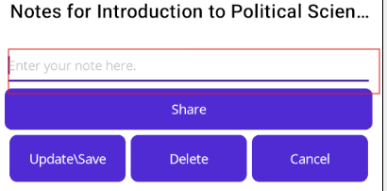
    - Click Update\Save
    - Return to the recently created note.
    - Use the Share button to bring up the sharing window.
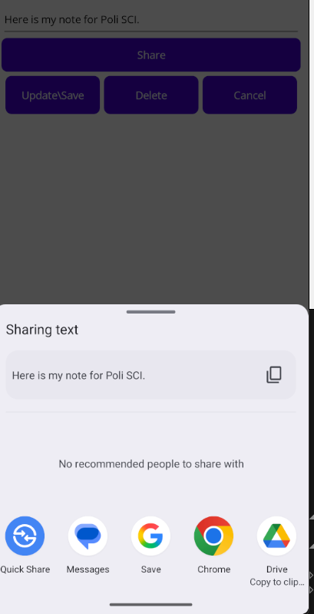

Git Logs
The git logs generated for this project are contained in the images below.
Commits to the D424 Capstone repository in GitLab.
WGU GitLab Environment / Student Repos / ghamme3 / D424 Software Engineering Capstone · GitLab
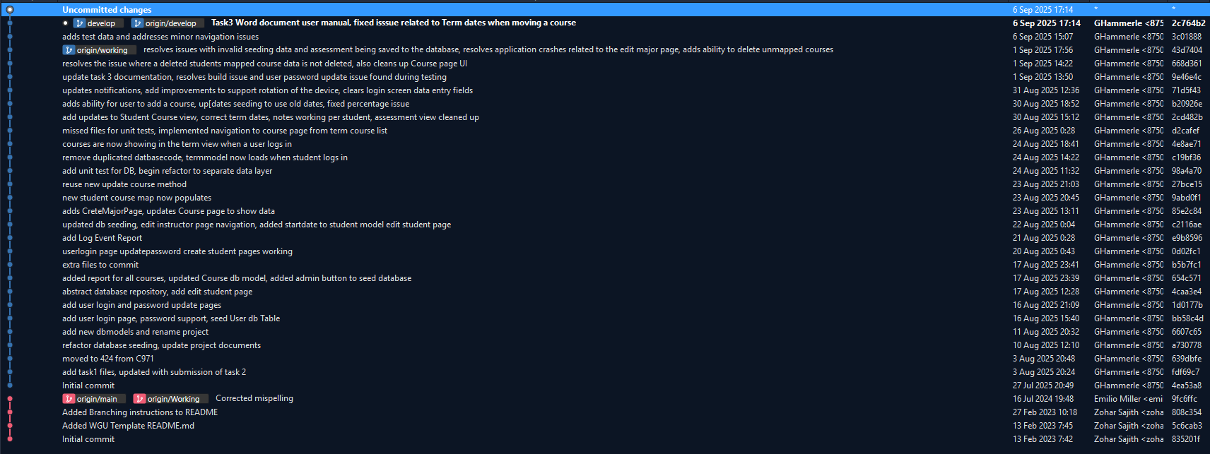
Commits that created the code “Moved from C971”
WGU GitLab Environment / Student Repos / ghamme3 / C971 Mobile Application Development Using C Sharp · GitLab